##### **Hiring Process Analytics**

**Project Description **

Provided dataset of an MNC company

1.Data is about people who registered for a particular post in a department of this company.

2.As an analyst I required to use my knowledge in statistics and use different formulas in excel and draw necessary conclusions about the company.

3, Draw insights out of it for hiring department to work upon.

4, Attributes of data

5.application_id

6, Interview Taken on

7, Status event name

8.Department

9, Post Name

10, Offered Salary

**Approach**

• Open data in Excel

Try to understand the problem and given questions

• Approach to familiar with the attributes and validate given data.

• Create table format and use count if, min, max, avg. and other statistical formulas.

• Analyzed data by using pivot table and pivot chart.

• Solve the given problems step by step and create interactive graphs

• Save excel file in csv format and create report for presentation.

**Tech-Stack Used**

1. MY EXCEL
2. MY WORD
3. MY SQL
4. GOOGLE DRIVE

**Insights & Result**

1. How many males and females are Hired?

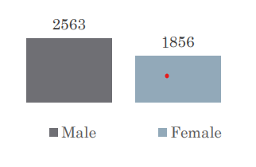

2. What is the average salary offered in this company?

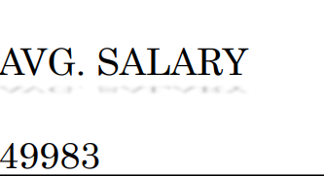

3. Draw the class intervals for salary in the company?

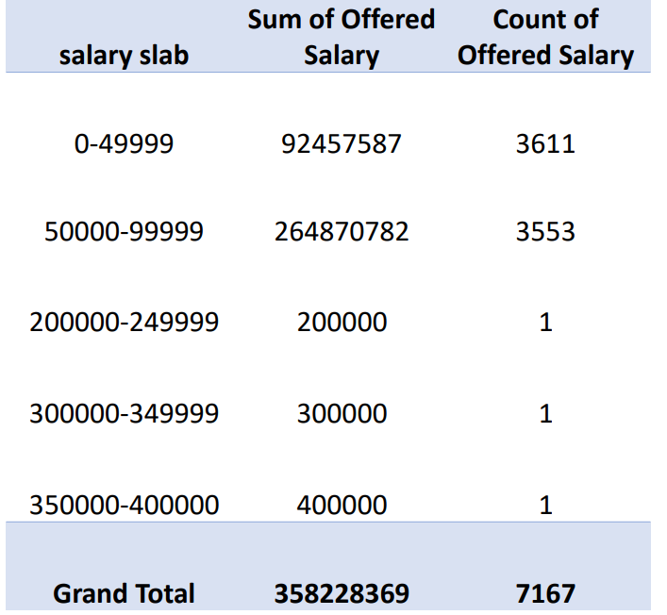

4.Draw Pie Chart / Bar Graph (or any other graph) to show proportion of people working different department?

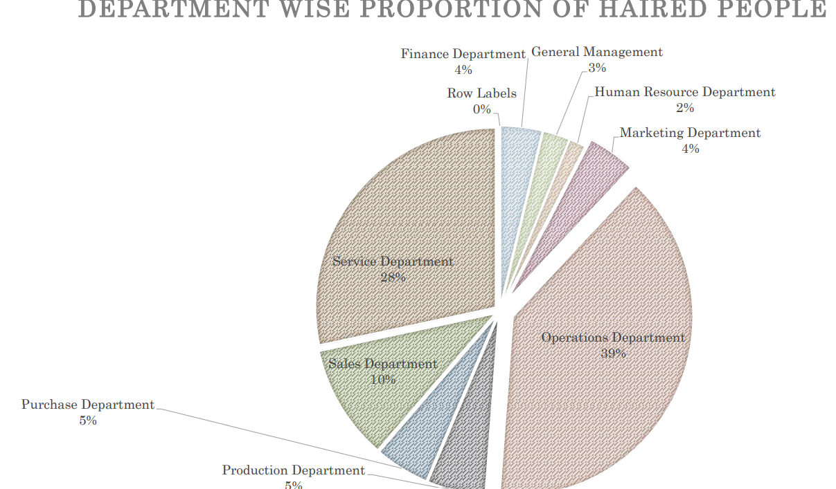

5. Represent different post tiers using chart/graph?

count of Hired As per Post

